Quarch Technology Ltd

AN-021

Application Note

QPS automation and post processing

For use with:

**XLC Power Modules  
HD Power Modules  
PAM**

**Quarch Power Studio (QPS)**

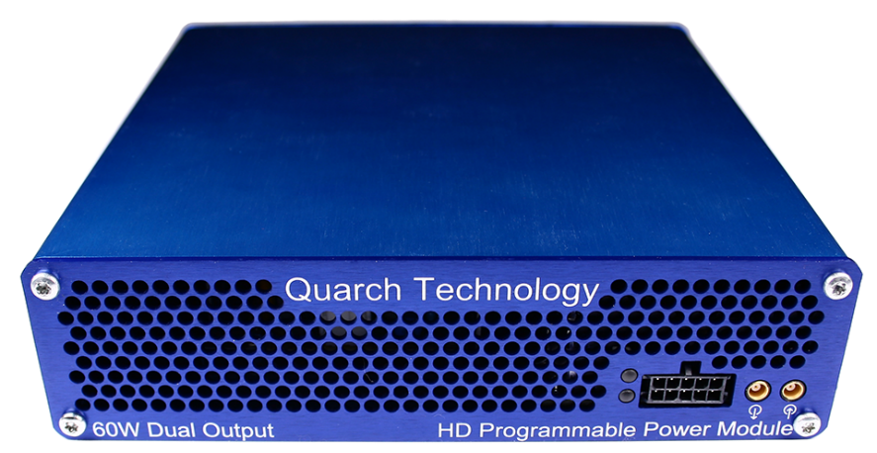

# Change History

|  |  |  |
| --- | --- | --- |
| 1.0 | June 2020 | Initial Release |
|  |  |  |
|  |  |  |
|  |  |  |
|  |  |  |

Contents

Change History 2

Introduction 4

Modules Supported 5

System Supported 5

Application Note Example Files 5

Installation and setup 5

Python install 5

QuarchPy library install 6

Java install 8

QPS install 8

FIO install 8

Power module setup 9

Running the example 10

# Introduction

Quarch Power Studio (QPS) is a unique system for recording and analyzing power consumption of storage devices. This application note demonstrates the ability to automate QPS and extract the data for additional post processing using Python

# Modules Supported

XLC power modules

* QTL1824 (QTL1824-02A modules do NOT support streaming, but can be upgraded by Quarch)
* QTL1847

HD power modules

* QTL1995
* QTL1999

PAM modules

* QTL2312

# System Supported

This example is written and tested on Windows, though could be used on MacOS and Linux.

It currently requires Python 3.x

## Application Note Example Files

The **AN-017.zip** should be extracted to your preferred location.

|  |  |
| --- | --- |
| PowerExample.py | Main python file to execute |

# Installation and setup

## Python install

If you do not already have Python 3.x installed, download and install it from:

<https://www.python.org/downloads/>

Under Windows it is helpful to make sure the Python installation directory and PythonXX\Scripts are included in the PATH environment variable. See:

## [https://docs.python.org/3/using/windows.html#excursus-setting-environment-variables](https://docs.python.org/3/using/windows.html" \l "excursus-setting-environment-variables)

## QuarchPy library install

The Quarch Python package can be installed from the Python web repository (assuming you have internet access) or via the download from our website.

Quarchpy will also install a version of Quarch Power Studio

### Web Install

From the command line:

**>pip install quarchpy**

If this fails, your path to “pip” may not be set, you can instead run:

**>python –m pip install quarchpy**

### Local Install

If you want to install from a downloaded folder, ensure the folder is unzipped to a local disk, navigate to the folder containing the setup.py file and run (noting the ‘.’ on the end):

**>pip install quarchpy .**

If this fails, your path to ‘pip’ may not be set, you can instead run:

**>python –m pip install quarchpy .**

### Upgrade

If you already have QuarchPy installed, you will get a failure message. If you want to upgrade to a new version, you need to add the ‘--upgrade’ command:

**>pip install --upgrade quarchpy**

The --upgrade command can similarly be used in any of the other examples, to load from a local install folder.

## Java install

Check that the Java JRE is installed

You can find install instructions and files here:  
<http://www.oracle.com/technetwork/java/javase/downloads/index.html>

## QPS install

Current versions of QPS are provided as a portable (non-install) .jar file and a windows installer

The latest version can be downloaded from here:  
<https://quarch.com/products/quarch-power-studio>

## Power module setup

Connect the power module to the test PC and the output of the power module to the drive under test.

Customer Drive

USB/LAN Connection

Power Module

Customer Test PC

# Running the example

* Execute PowerExample.py
* Select a module to connect with on the console
* Recording will begin automatically and runs for 5 seconds by default
* The raw CSV file will be saved
* Next 3 post processed files will be created from the raw data, at different sampling rates.